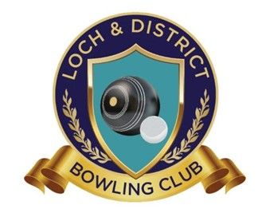

**Loch & District Bowling Club**

**24 Smith St, Loch Vic 3945**

**Ph: (03) 5659 4359**

**Email:** [**board@lochdistrictbowlingclub.com.au**](mailto:lochbowlsclub@gmail.com)

**ABN:-  199 122 026 27**

Venue Hire Agreement Between Loch & District Bowling Club And Non-Member:

|  |  |  |  |
| --- | --- | --- | --- |
| Name |  | Email |  |
| Contact Phone Number |  | Date of Function |  |
| Start Time |  | Finish Time |  |
| Type of Function |  | Approx No Guests |  |

Conditions of Hire apply: (refer Conditions of Hire & Information Sheet for full details)

* The function booking is not confirmed until the Security bond payment has been received.
* All drinks consumed during the function must be purchased from our bar. No BYO allowed.

# • Security Bond – (Compulsory - will be returned after inspection) $300

Charges: Select desired Hire Options (pricing based on 2 hr hire. Additional fee ($100 per hour) applicable for extra hours)

• Hire of Clubroom, Kitchen, BBQ & Licensed Bar (outside caterer/self-catered) $300



• Hire of Clubroom, Licensed Bar & Catered by Loch & District Bowling Club $200

# Funeral: $15.00 per person

NOTE: Final number of guests for Catering is required a minimum of 5 days in advance. Once final figures are given, you will be charged based on this figure. If additional guests attend, they will incur an additional charge.

• EFTPOS available

We agree to the charges stated above and enclose a cheque, cash or direct deposit of $........................ which includes payment of the Security Bond.

|  |  |
| --- | --- |
| signed | date |

Direct Deposit Details:

Update: May 2025